Assignment 2

Working with EC2 instances

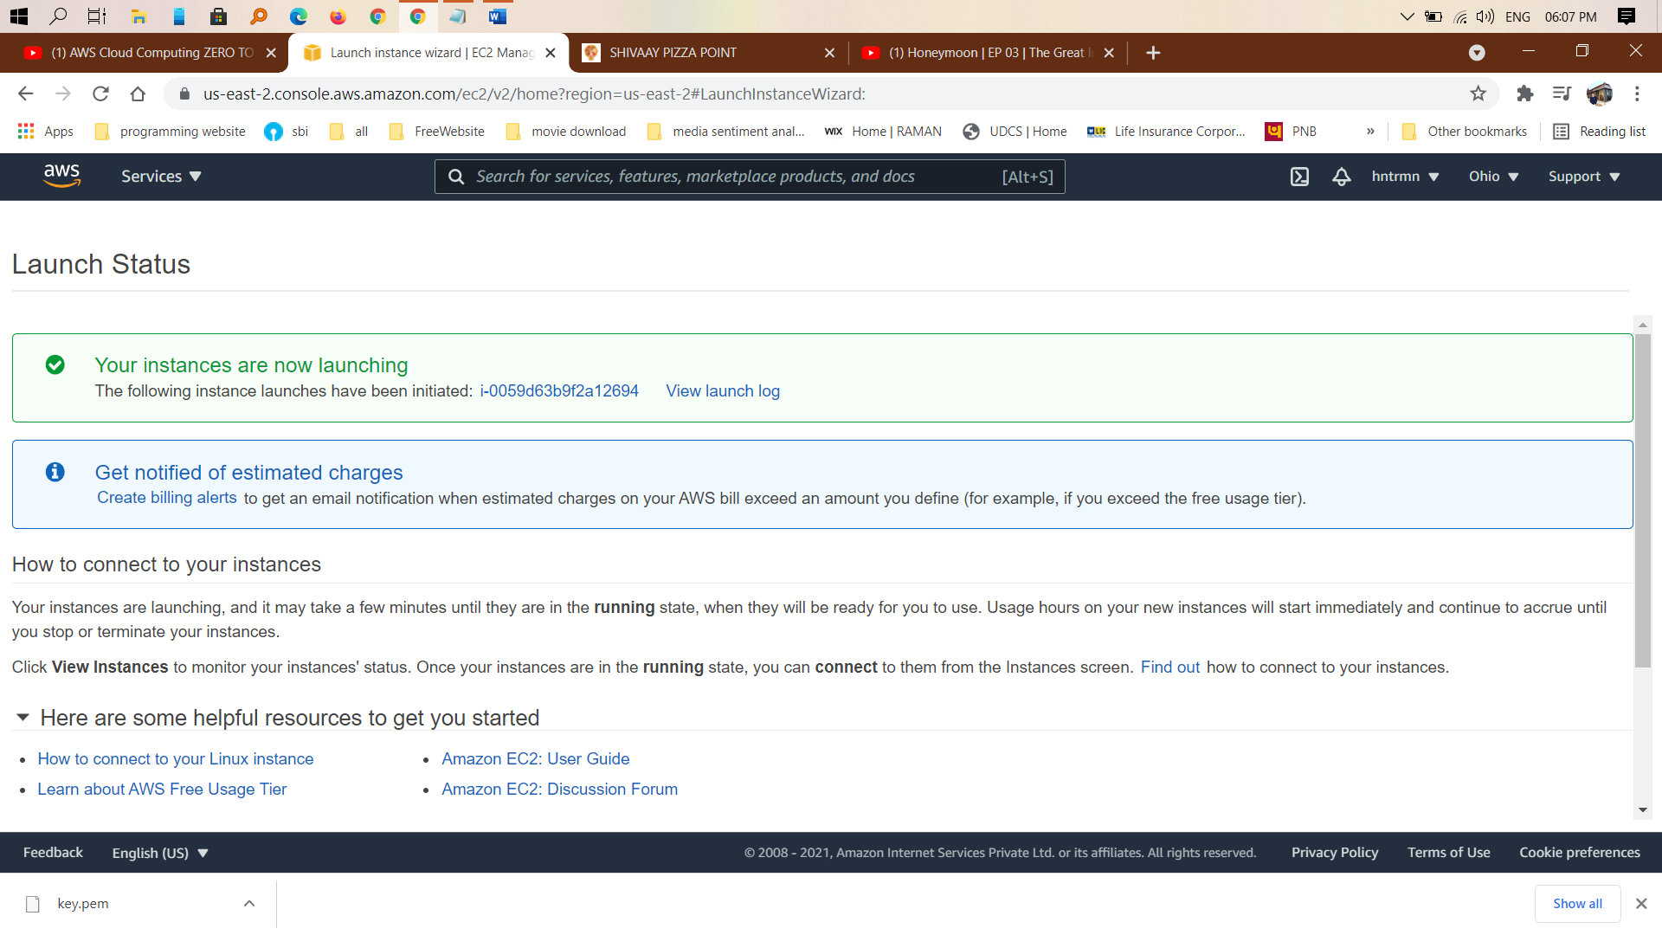Create a EC2 instance.

Connect to the instance.

